* In [computer science](http://www.wikipedia.org/wiki/Computer_science), **linear search** or **sequential search** is a method for finding a particular value in a [list](http://www.wikipedia.org/wiki/List_%28computing%29), which consists of checking every one of its elements, one at a time and in sequence, until the desired one is found.
* Linear search is the simplest [search algorithm](http://www.wikipedia.org/wiki/Search_algorithm).

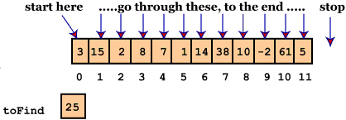

* **Applications:**





**Procedure:**

* The Linear Search is applied on the set of items that are not arranged in any particular order
* In linear search , the searching process starts from the first item.
* The searching is continued till either the item is found or the end of the list is reached indicating that the item is not found.
* The items in the list are assumed to be unique.